Project Title
Full Stack Notes Management Application

1. Project Overview
This project is a Full Stack Notes Management Application developed using React.js, Node.js, Express.js, and MongoDB. The application allows users to securely create, view, edit, and delete personal notes after authentication. It demonstrates practical implementation of MERN stack concepts such as authentication, CRUD operations, RESTful APIs, and frontend–backend integration.

2. Objectives of the Project
- To develop a secure notes management system
- To implement user authentication and authorization
- To perform CRUD operations on notes
- To understand frontend and backend integration
- To follow professional project structure and best coding practices

3. Technology Stack

Frontend
- React.js (with Hooks)
- React Router DOM
- CSS

Backend
- Node.js
- Express.js

Database
- MongoDB
- Mongoose

4. Project Architecture
The application follows a Client–Server Architecture:
- Frontend (React) handles user interface and interactions
- Backend (Node + Express) manages APIs and authentication
- MongoDB stores user and notes data securely

5. Core Features
- User authentication (Login & Register)
- Create new notes
- Edit existing notes
- Delete notes
- View all saved notes

6. Functional Modules

6.1 User Authentication Module
- User registration
- User login
- Protected routes using authentication middleware

6.2 Notes Management Module
- Add new notes
- Edit note content
- Delete notes
- Display all notes in dashboard

7. Project Directory Structure

Backend Structure
notes-app/
├── backend/
│ ├── server.js
│ ├── config/
│ │ └── db.js
│ ├── models/
│ │ ├── User.js
│ │ └── Note.js
│ ├── routes/
│ │ ├── authRoutes.js
│ │ └── noteRoutes.js
│ ├── controllers/
│ │ ├── authController.js
│ │ └── noteController.js
│ └── middleware/
│ └── authMiddleware.js

Frontend Structure
frontend/
├── src/
│ ├── components/
│ │ ├── NoteCard.jsx
│ │ ├── NoteForm.jsx
│ │ └── Navbar.jsx
│ ├── pages/
│ │ ├── Login.jsx
│ │ ├── Register.jsx
│ │ └── Dashboard.jsx
│ ├── App.jsx
│ └── main.jsx
└── package.json

8. User Interface Description

Dashboard Page
- Display all notes
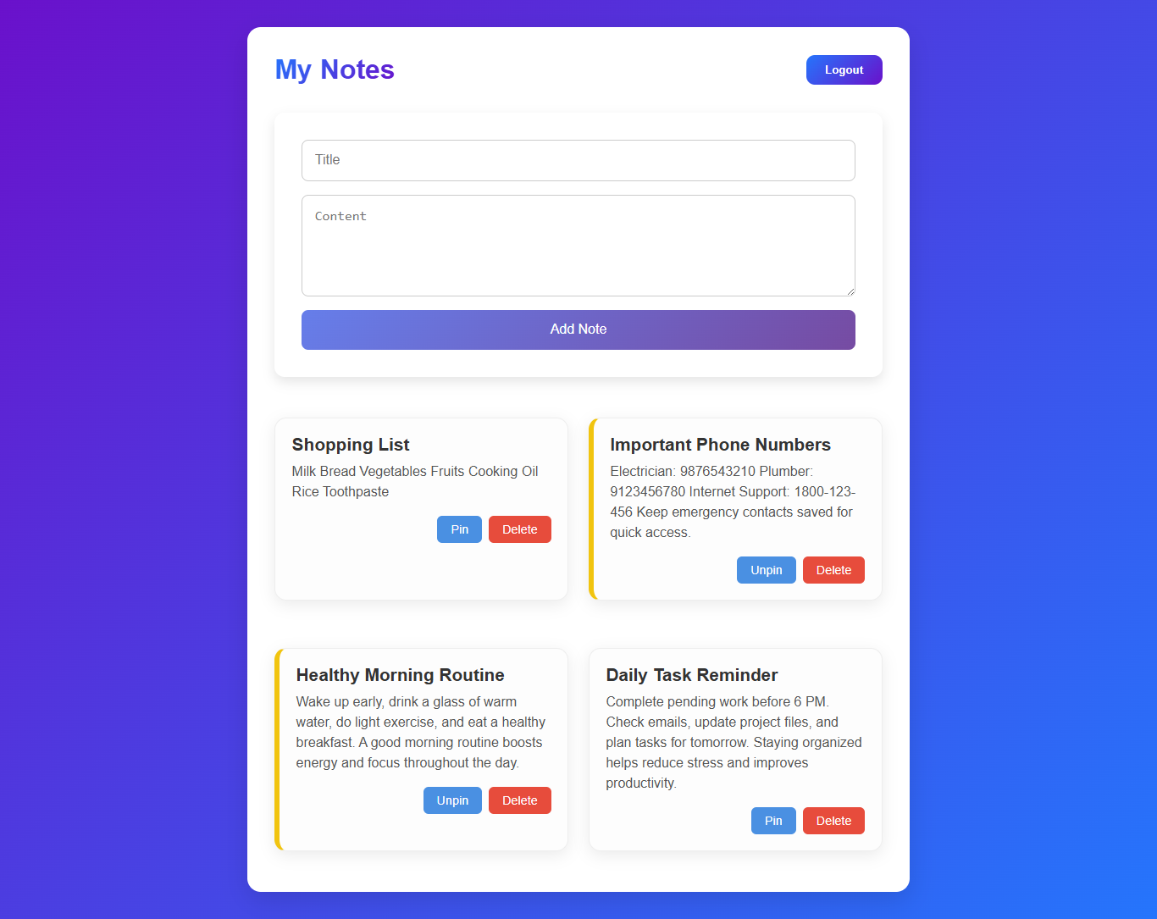
- Options to add, edit, and delete notes

Login page
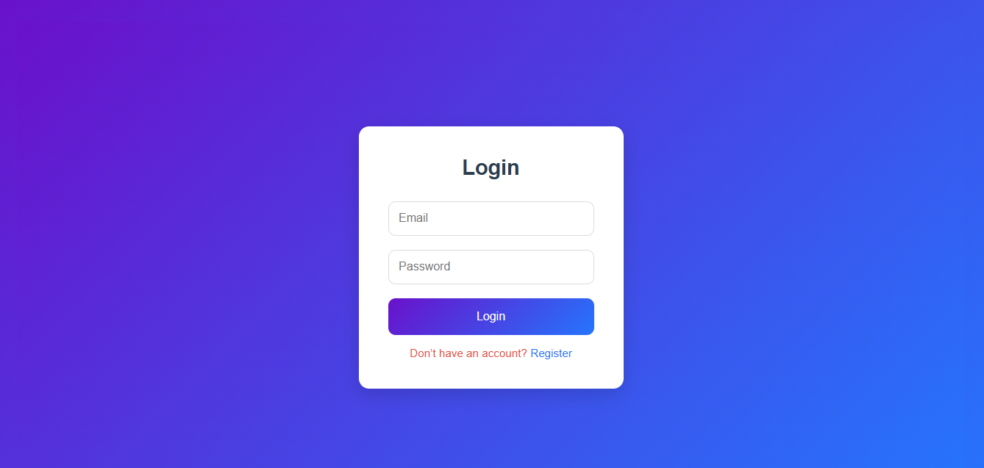
- User login form with validation

Register Page
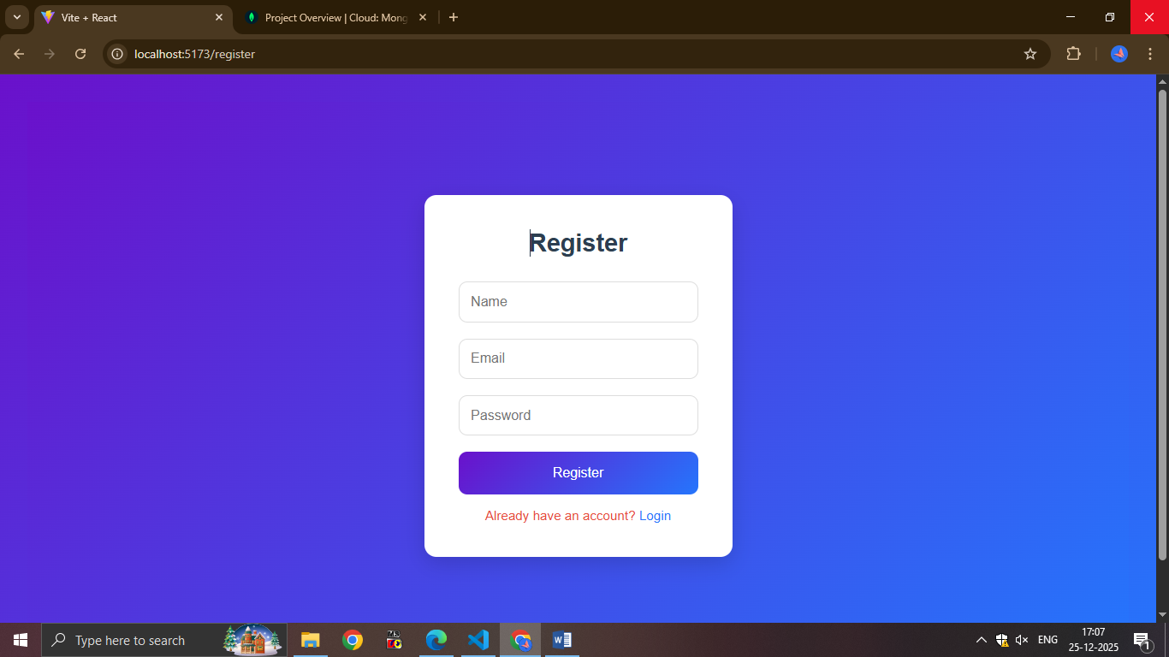
- New user registration form

9. Security & Validation
- Authentication middleware for protected routes
- Input validation on frontend and backend
- Secure database connection using environment variables

